A Comparison of Hydrophobic and Oleophobic Silicon Surfaces
David A. Smith
SilcoTek Corporation
112 Benner Circle
Bellefonte, PA 16823
www.SilcoTek.com

Contact Angle Evaluation of SilcoTek Depositions
Project Overview: To evaluate and discuss the significance of contact angle data for two different liquids on a variety of SilcoTek surfaces. SilcoNert 2000, SilcoKlean, Silcolloy, Dursan and a Dursan-based prototype will be highlighted.
Purpose: The analysis of interaction of a liquid with a surface can provide a simple but powerful understanding of the surface’s characteristics and how it will perform in other related environments. Contact angle data using liquids of known surface tensions can provide an insightful characterization of a surface that has been tailored to exhibit desirable functions.
For example, a high contact angle with water translates to a hydrophobic surface that may display rapid dry down properties for tubing subjected to gas streams contaminated with water vapor. This may in turn prevent localized corrosion as the water vapor is less likely to pool and corrode the tubing over time.
Another surface with a high contact angle for hexadecane translates to an oleophobic surface. A highly oleophobic material may prevent the accumulation of hydrocarbon-based material in fuel delivery systems or combustive exhaust systems, thereby allowing a higher degree of performance efficiency and power output.
Experimental: SilcoTek has two instruments for contact angle analysis: a Krüss K100 tensiometer and a Ramé-Hart Model 200 goniometer. Both systems provide valuable information when evaluating the interactive forces between a known liquid and a test surface. The tensiometer is excellent at providing bulk-analysis of a larger surface area, generating advancing and receding contact angle values. The goniometer is a fixed level stage system (i.e. no tilt) that can provide a localized equilibrium contact angle. It is also excellent at providing a visual identification of the solid/liquid/air interaction.
The test substrate will be 316L stainless steel in two different surface finishes: a corrosion coupon with a 120 grit finish, and a sample coupon with a “mirror finish” surface. Since surface topology can have an effect on the equilibrium contact angle data (measured with the goniometer), a wide variance of roughness was used to help bracket the performance expectations of each surface. The same variance in surface roughness was used in the tensiometer measurements, but the nature of that measurement (bulk dip vs. localized drop) is not overtly sensitive to those variations.
Data:
Table I. Average (n=5) tensiometer advancing and receding contact angles; DI water
 | Advancing | Receding
Silcolloy 1000 | 28.3 | 0.0
SilcoNert 2000 | 83.0 | 47.0
Dursan | 96.2 | 70.9
Prototype Dursan | 125.1 | 93.6

Figure 1. Comparative advancing and receding DI water contact angle data from tensiometer
Table II. Average goniometer static contact angles for rough vs. smooth; DI water
 | Rough (n=9) | Smooth (n=6)
Silcolloy 1000 | 53.5 | 29.4
SilcoNert 2000 | 99.4 | 74.1
Dursan | 119.3 | 86.0
Prototype Dursan | 146.7 | 112.1

Figure 2. Comparative advancing and receding DI water contact angle data from tensiometer

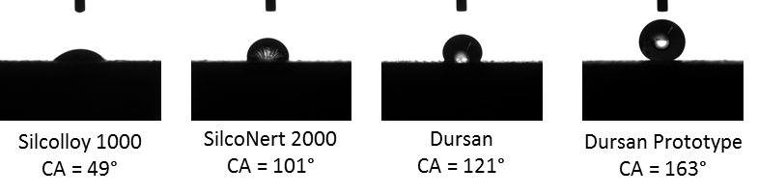
Figure 3. Goniometer contact angle (CA) photos; DI water on treated surfaces: Rough

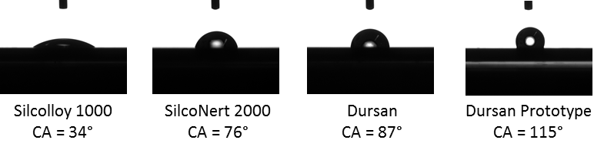
Figure 4. Goniometer contact angle (CA) photos; DI water on treated surfaces: Smooth

Table III. Average (n=5) tensiometer advancing and receding contact angles; hexadecane
 | Advancing | Receding
Silcolloy 1000 | 0.0 | 0.0
SilcoNert 2000 | 0.0 | 0.0
Dursan | 0.0 | 0.0
Prototype Dursan | 52.8 | 20.2

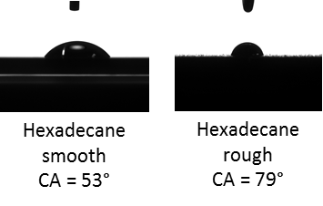
Figure 5. Goniometer drop photos for hexadecane on Dursan Prototype surface

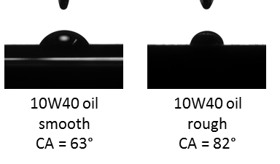
Figure 6. Goniometer drop photos for 10W40 motor oil on Dursan Prototype surface

Measurement Discussion:
Contact angle data, depending on the measurement type and surface, can appear to be quite variable. The advancing and receding data obtained on the Krüss Tensiometer (Table I and Figure 1) provide accurate characterization of a bulk surface, as part of the test piece is progressively immersed in to and removed from the measurement liquid. Advancing data is acquired as the liquid is pushed in to the coated coupon, and receding data is acquired as the liquid is pulled away from the coated coupon. More information on this experiment can be obtained at www.krussusa.com. Surface roughness (i.e. smooth vs. rough) on a bulk measurement such as this did not have a significant effect on the tensiometer contact angle data, and therefore each data point in Table I and Figure 1 are averaged from 3 rough and 2 smooth coupons.
The Ramé-Hart Goniometer data (Table II and Figure 2) are from 2ul drops of water on to several localized coupon points. Variability in this measurement is obvious when comparing a rough and smooth surface with the same surface material. For coupons of the same coating, they were deposited simultaneously and therefore have the same surface chemistry – the only difference is surface topography. The Goniometer data is averaged from each local contact area between the liquid drop and the coupon surface and segregated by smooth vs. rough. Equilibrium contact angles such as these often fall between the advancing/receding bulk contact angle values obtained by the tensiometer. Further technical information about contact angle measurement can be found at www.ramehart.com.
For hydrophobic surfaces, the advancing/receding data can reflect an interesting observable physical phenomenon. As the receding contact angle becomes closer to the advancing angle, the surface exhibits a Cassie-Baxter state, whereby the droplet can move around the surface with varying tilt. A Wetzel state is noted when there is further inequality between advancing/receding data points (see Appendix for a comparative illustration) and there is little to no droplet mobility with tilt. A Cassie-Baxter state is highly desirable when considering a surface that requires water repellency and surface topography can also have an effect on this characteristic.

Results and Discussion - Hydrophobicity:
The progressive increase of water contact angle shown in Tables I & II and Figures 1 & 2 are the result of strategic engineering through surface science and functionalization. The lowest contact angles were measured Silcolloy 1000. Silcolloy 1000 is a patented¹ multilayered amorphous silicon CVD material with a native oxide surface that is relatively hydrophilic in nature. It is best suited for anti-corrosive applications, particularly for acidic and salt media.
SilcoNert2000 is also an amorphous silicon CVD material, but is surface functionalized with a covalently-bonded hydrocarbon² to dramatically improve its inertness qualities and hydrophobicity. Because of its unprecedented inertness and good hydrophobicity, SilcoNert 2000 is commonly applied to analytical and sampling systems used in chromatography supplies, oil and gas sampling media, and chemical processes transfer tubing, valves and fittings.
Dursan is a carboxysilane CVD coating with a functionalized hydrocarbon surface.³ Dursan is highly inert, wear resistant, and is an excellent anti-corrosive barrier for acidic and basic media, yet is the most hydrophobic coating commercially available from SilcoTek. It also has a narrow advancing/receding hysteresis so that it exhibits a Cassie-Baxter characteristic, even on a mirror-smooth surface. The combination of four characteristics: inertness, wear-resistance, anti-corrosion, and hydrophobicity make Dursan an excellent addition to analytical and transfer systems/components that require precise media transfer without the negative accumulative effects of humidity or moisture, or surface reactivity.
SilcoTek is currently developing a new CVD deposition specifically designed to be highly hydrophobic, oleophobic, and thermally and oxidatively stable.⁴ This type of coating should find application opportunities where high hydrophobicity is necessary, and perhaps also in antifouling and anticoking applications. Using Dursan chemistry as a foundation, a prototype material has been developed to exhibit the highest level of hydrophobicity and oleophobicity of any SilcoTek coating. Tensiometer data showed an average advancing water contact angle of 125.1° and an average receding of 93.6°. Average equilibrium contact angle was 146.7° for a rough surface and 112.1° for a mirror surface.
Figure 3 water droplet photographs illustrate the progression from hydrophilic to hydrophobic surfaces on the rough surface coupons. The extreme case for the Dursan prototype generated a contact angle of 163°. The droplet for that coupon had to be larger than the standard 2ul size, as the drop would not release to the Dursan Prototype surface until it was large enough for its own weight to pull it away from the syringe needle tip. Figure 4 is a series of photos corresponding to Figure 3, but with droplets on coated mirror-finish coupons.

Results and Discussion - Oleophobicity:
Oleophobic surfaces have become desirable for many materials from glass used in cell phone and computer tablets to resist fingerprints, to fuel delivery and exhaust systems to resist fouling and coke accumulation. Table III shows how none of the commercially available SilcoTek materials have much oleophobic character when measured with hexadecane. However, the Dursan Prototype exhibits significant oleophobic character with measureable advancing and receding tensiometer contact angles, and significant localized equilibrium contact angles of 53° (smooth) and 79° (rough) illustrated in Figure 5. Using 10W40 motor oil as a droplet liquid (Figure 6), the Dursan Prototype exhibited further oleophobicity with contact angles of 63° (smooth) and 82° (rough). Additionally, the Dursan Prototype is transparent to visible light when applied to glass. Research of this new material is ongoing, particularly in the characterization of inertness, wear-resistance and friction coefficient. Contact angle data, however, reveal a material that may be highly applicable when hydrophobicity and/or oleophobicity characteristics are required.
Conclusions:
The classification of surface energy by contact angle of SilcoTek CVD depositions is a significant step in helping customers understand the performance of a coating for their particular application. For applications requiring a high degree of hydrophobicity as well as inertness, corrosion resistance and wear resistance, Dursan is the coating of choice. SilcoNert 2000 is also an excellent recommendation, particularly if inertness is an utmost requirement. Some applications require hydrophilicity, or surface energy is not a primary concern. It that case, Silcolloy 1000 is often an optimal choice for service requiring anti-corrosive performance. Finally, SilcoTek continues to develop new materials to meet customer needs, and a current prototype is showing significant promise when hydrophobic and oleophobic qualities are required.

Appendix:
Illustration of differences between Cassie-Baxter behavior (narrow advancing/receding hysteresis) and Wenzel behavior (wide advancing/receding hysteresis).
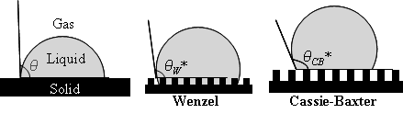
Source: Microstruct superhydrophobic.png. In Wikipedia. Retrieved August 23, 2012, from http://en.wikipedia.org/wiki/File:Microstruct_superhydrophobic.png

References:
¹US patent No. 6,511,760
²US patent Nos. 6,444,326 and 7,867,627
³US patent Application No. 20120251797 and PCT/US2011/054835
⁴US patent Application No. 61/615,559 and PCT writing in process

