Title: Why does the coating appear “cracked” on my evaluation coupon? – A tale of two sides
Initiated Date: 03-25-19
Submitted Date: 04-18-19
Author(s): Min Yuan

Background:
Recently, a customer reached out to SilcoTek to share a curious observation they made on the SilcoNert 2000-coated evaluation coupons. These were flat 316 stainless steel coupons that we provide to customers for free coating evaluation. The customer examined the coating under the SEM, and saw what appeared to be coating cracks (Figure 1).

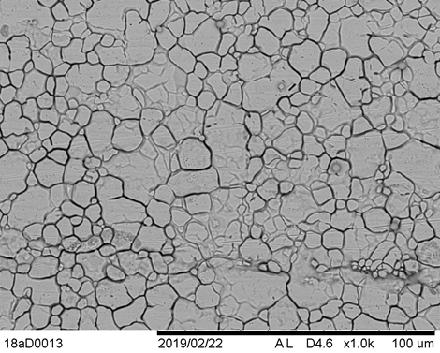
Figure 1) SEM image (1000x) of a SN2000-coated 316SS evaluation coupon shared by a SilcoTek customer
Upon receiving the customer’s feedback, SilcoTek’s R&D team started an investigation into the evaluation coupons. Samples from different production batches were pulled from the coupon stock for SEM inspection, and the “cracked” coupon was returned to SilcoTek for further examination.

Discussion / Data / Links:
The initial examination did not find any coupon that exhibited the same “cracked” pattern observed by the customer. Even the same coupon from the customer did not reproduce the SEM results. Meanwhile, the customer received two replacement coupons for evaluation, and reported similar cracks seen in the SEM of these coupons. What’s going on?
It turns out that the two sides of the evaluation coupons are not equivalent; one side has a mirror-polished finish, whereas the back side has a standard machine-finish (see Figure 2 below). With the coating on, it is not always immediately obvious by visual inspection which side has the polished finish. To look for one’s own reflection in the coupon is the easiest way to identify the two sides.
The SilcoTek internal investigation focused on the mirror side, as the polished side works better for most surface analysis techniques, and has become the “default” side for our characterizations. The customer, on the other hand, looked at the machine-finished side under the SEM. The differences in the finishes of the metal are responsible for this discrepancy.
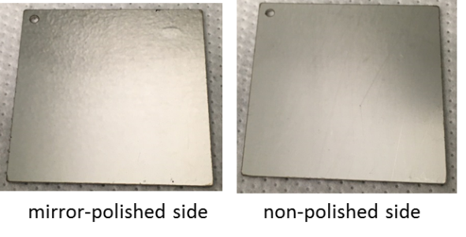
Figure 2) the two sides of an uncoated evaluation coupon
After realizing this, the unpolished side of the return coupon was examined under the SEM by SilcoTek, which revealed the “cracks” described by the customer. These “cracks” are in fact the stainless steel metal grains that become visible under high magnification, and after a mirror polish, are smoothed out and no longer show up under the SEM. Figures 3 and 4 below show both sides under the SEM (1000x) with coating on. To confirm that the “cracks” are indeed from the metal itself, uncoated as-received coupons were also examined under optical microscope, to demonstrate the differences of the two finishes on the two sides. Linear polarization resistance scans using 5% HCl solution as the electrolyte were also performed on both sides of a coated coupon. Actual coating cracks would inevitably lead to poor corrosion performance and would be detected by this test. The measured corrosion currents for both sides were comparable, further confirming the integrity of the coating itself on the non-polished side. 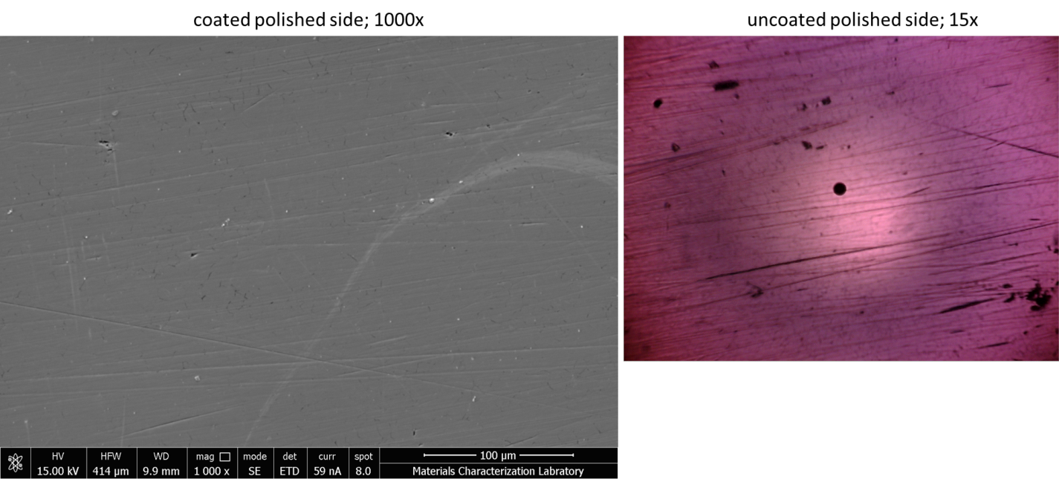
Figure 3) SEM (left) and optical microscope (right) images of the mirror-polished side of an evaluation coupon

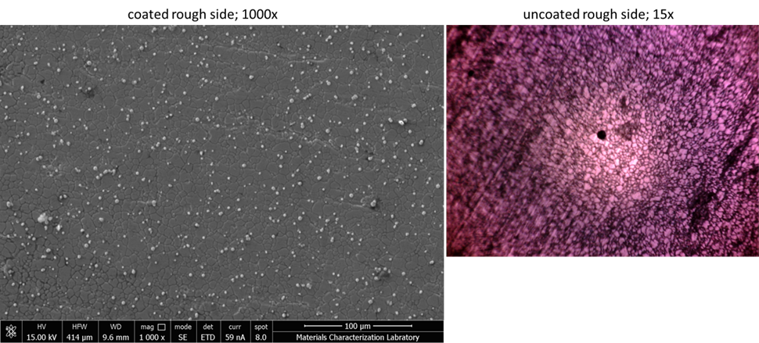
Figure 4) SEM (left) and optical microscope (right) images of the unpolished side of an evaluation coupon

Conclusion:
This TI summarizes an investigation in response to a customer complaint. The reported cracks in the coating observed by the customer in SEM were confirmed to be in fact stainless steel metal grains, as a result of the unpolished surface finish. SilcoTek’s CVD coating is very thin (sub-micron) and in general will not mask the microstructures of the underneath substrate. The features of the metal itself will show up in SEM examinations, and to minimize this, polished surfaces are usually preferred if one wishes to evaluate the surface morphology of the coating itself.

